Exp24:-
Title of the program:-
Write a C++ program to check a leap year.
Program instruction:-
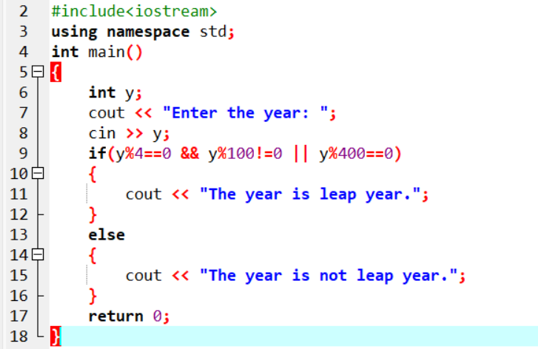
Output:-

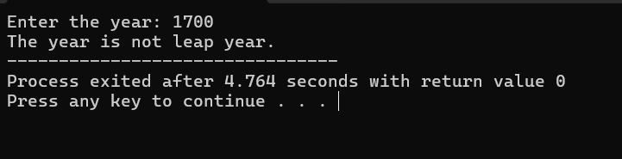

Exp25:-
Title of the program:-
Write a C++ program to reverse a number.
Program instruction:-

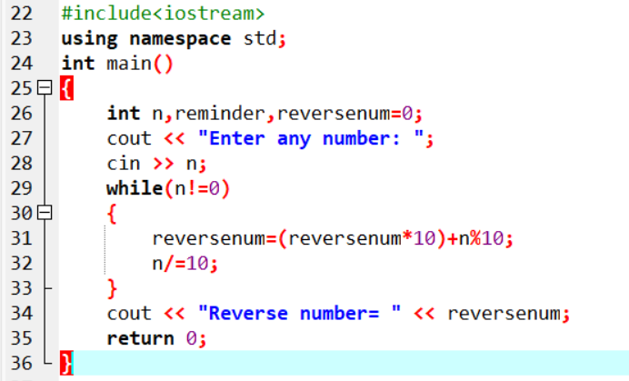

Output:-
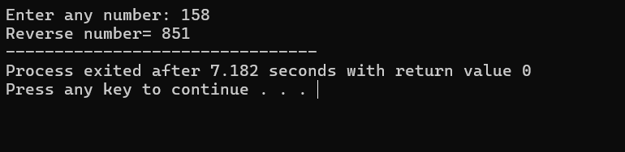

Exp26:-
Title of the program:-
Write a C++ program to find Harshad number between 1 to 1000(A number is called Harshad number if it is divisible by the sum of its digits).
Program instruction:-

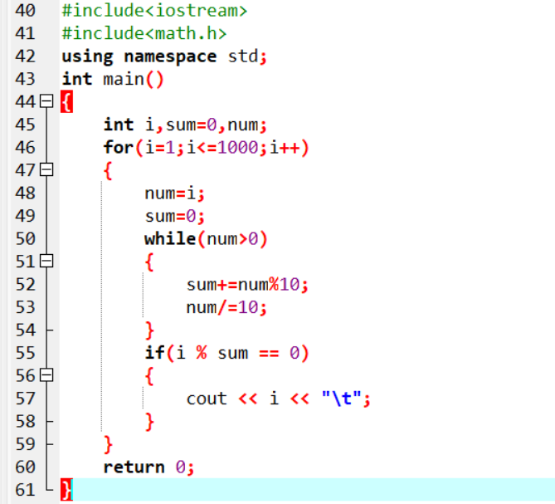
Output:-

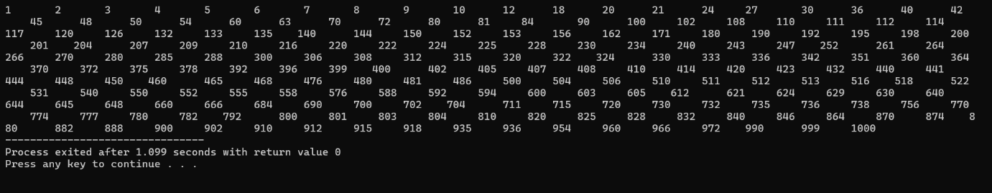

Exp27:-
Title of the program:-
Write a C++ program to convert a binary sequence to its corresponding decimal number.
Program instruction:-

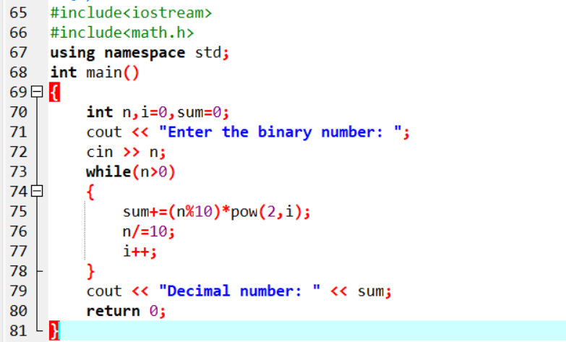
Output:-

